- \Operation\Ink-jet labeling\Settings
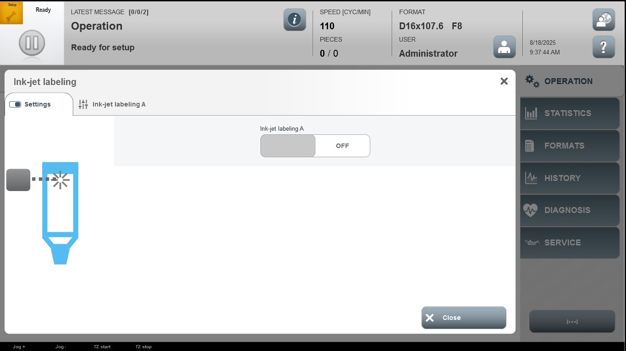

Acceptance criterion | Limits | Pass / Fail: Dev-No. | Date | Initials
Screen matches screenshot | N / A

